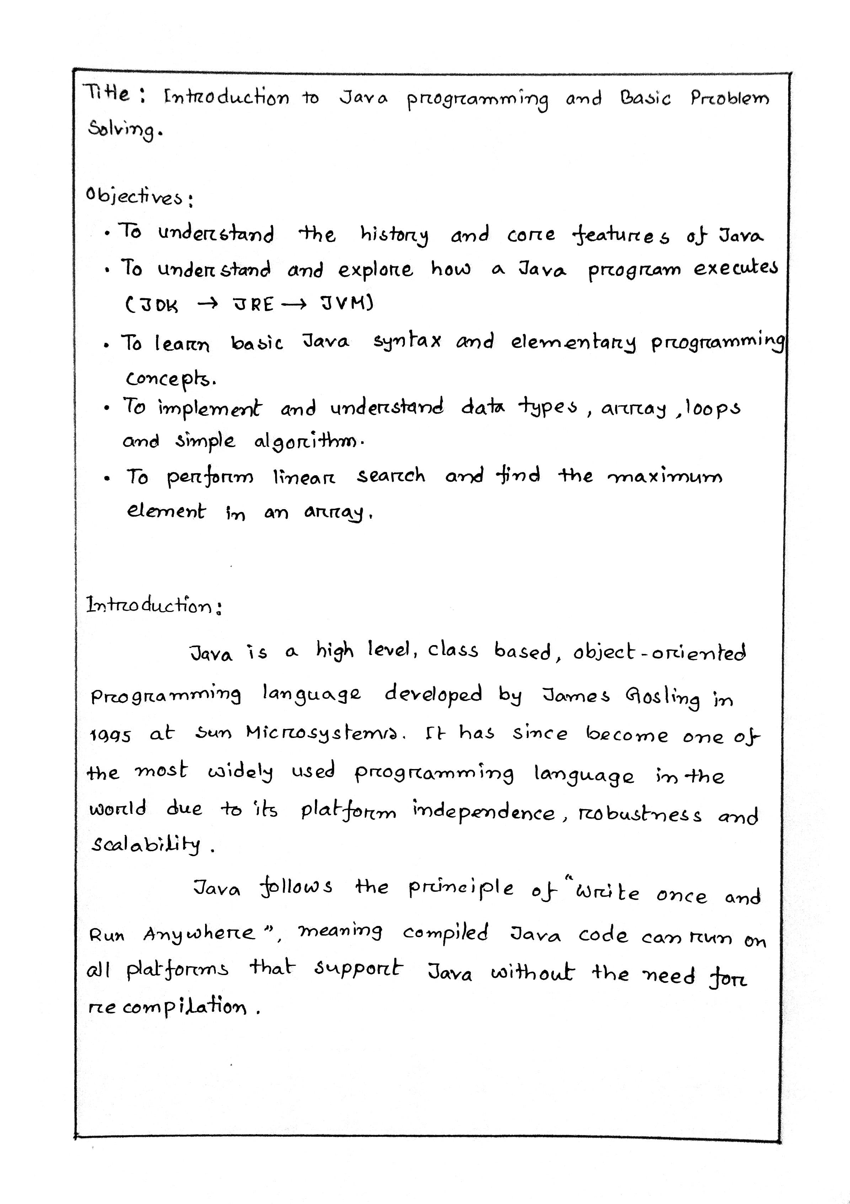

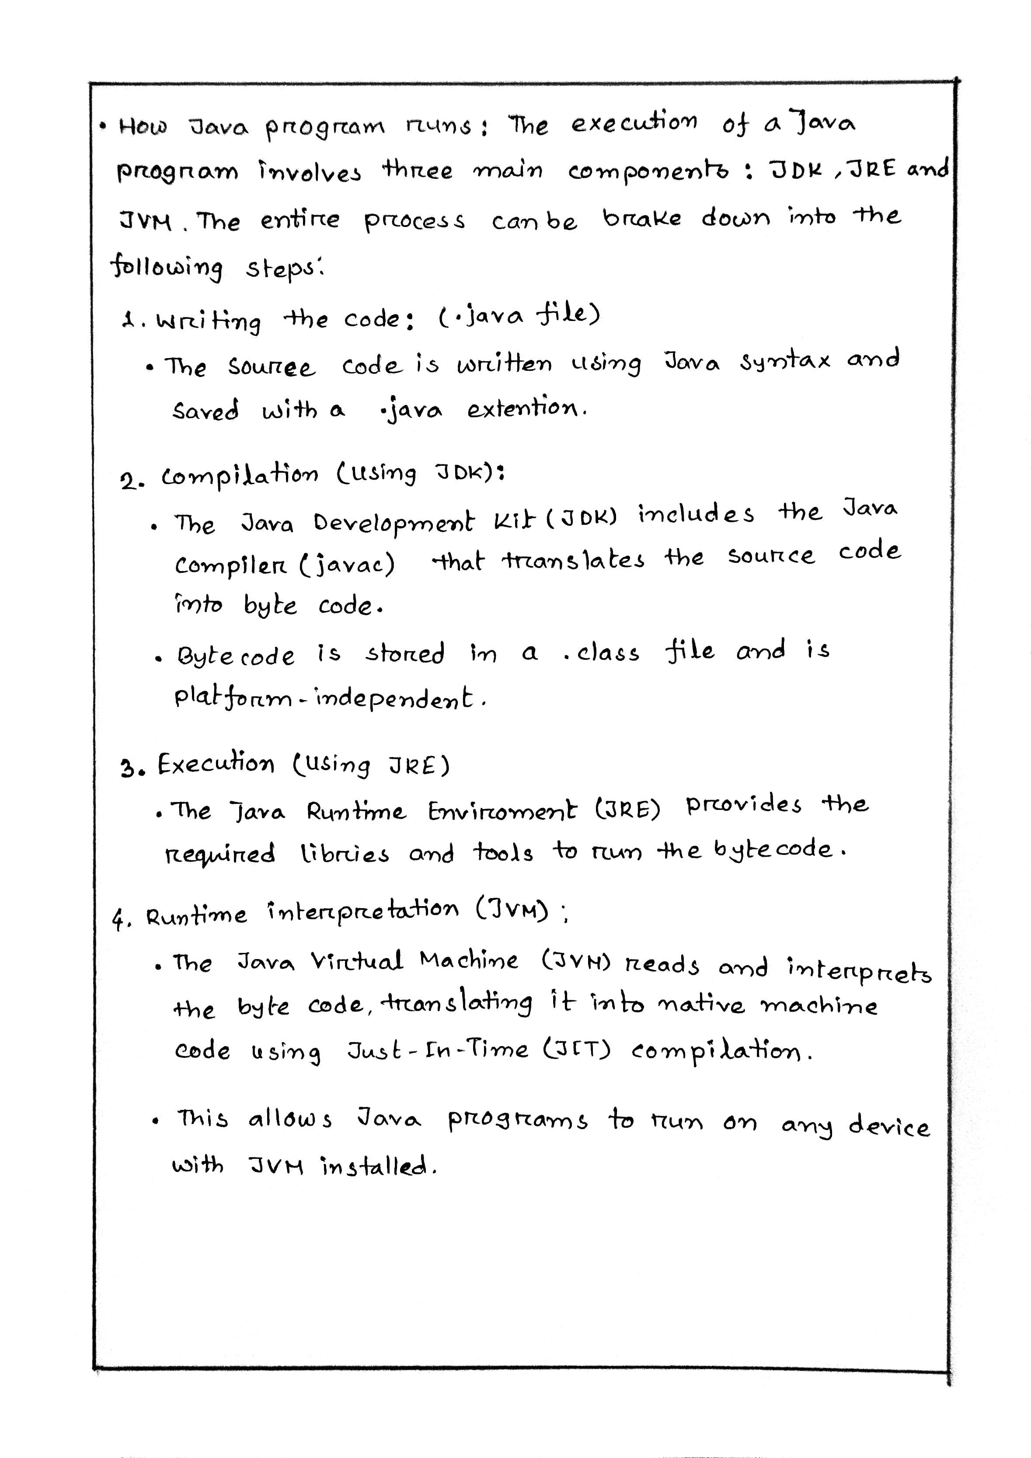
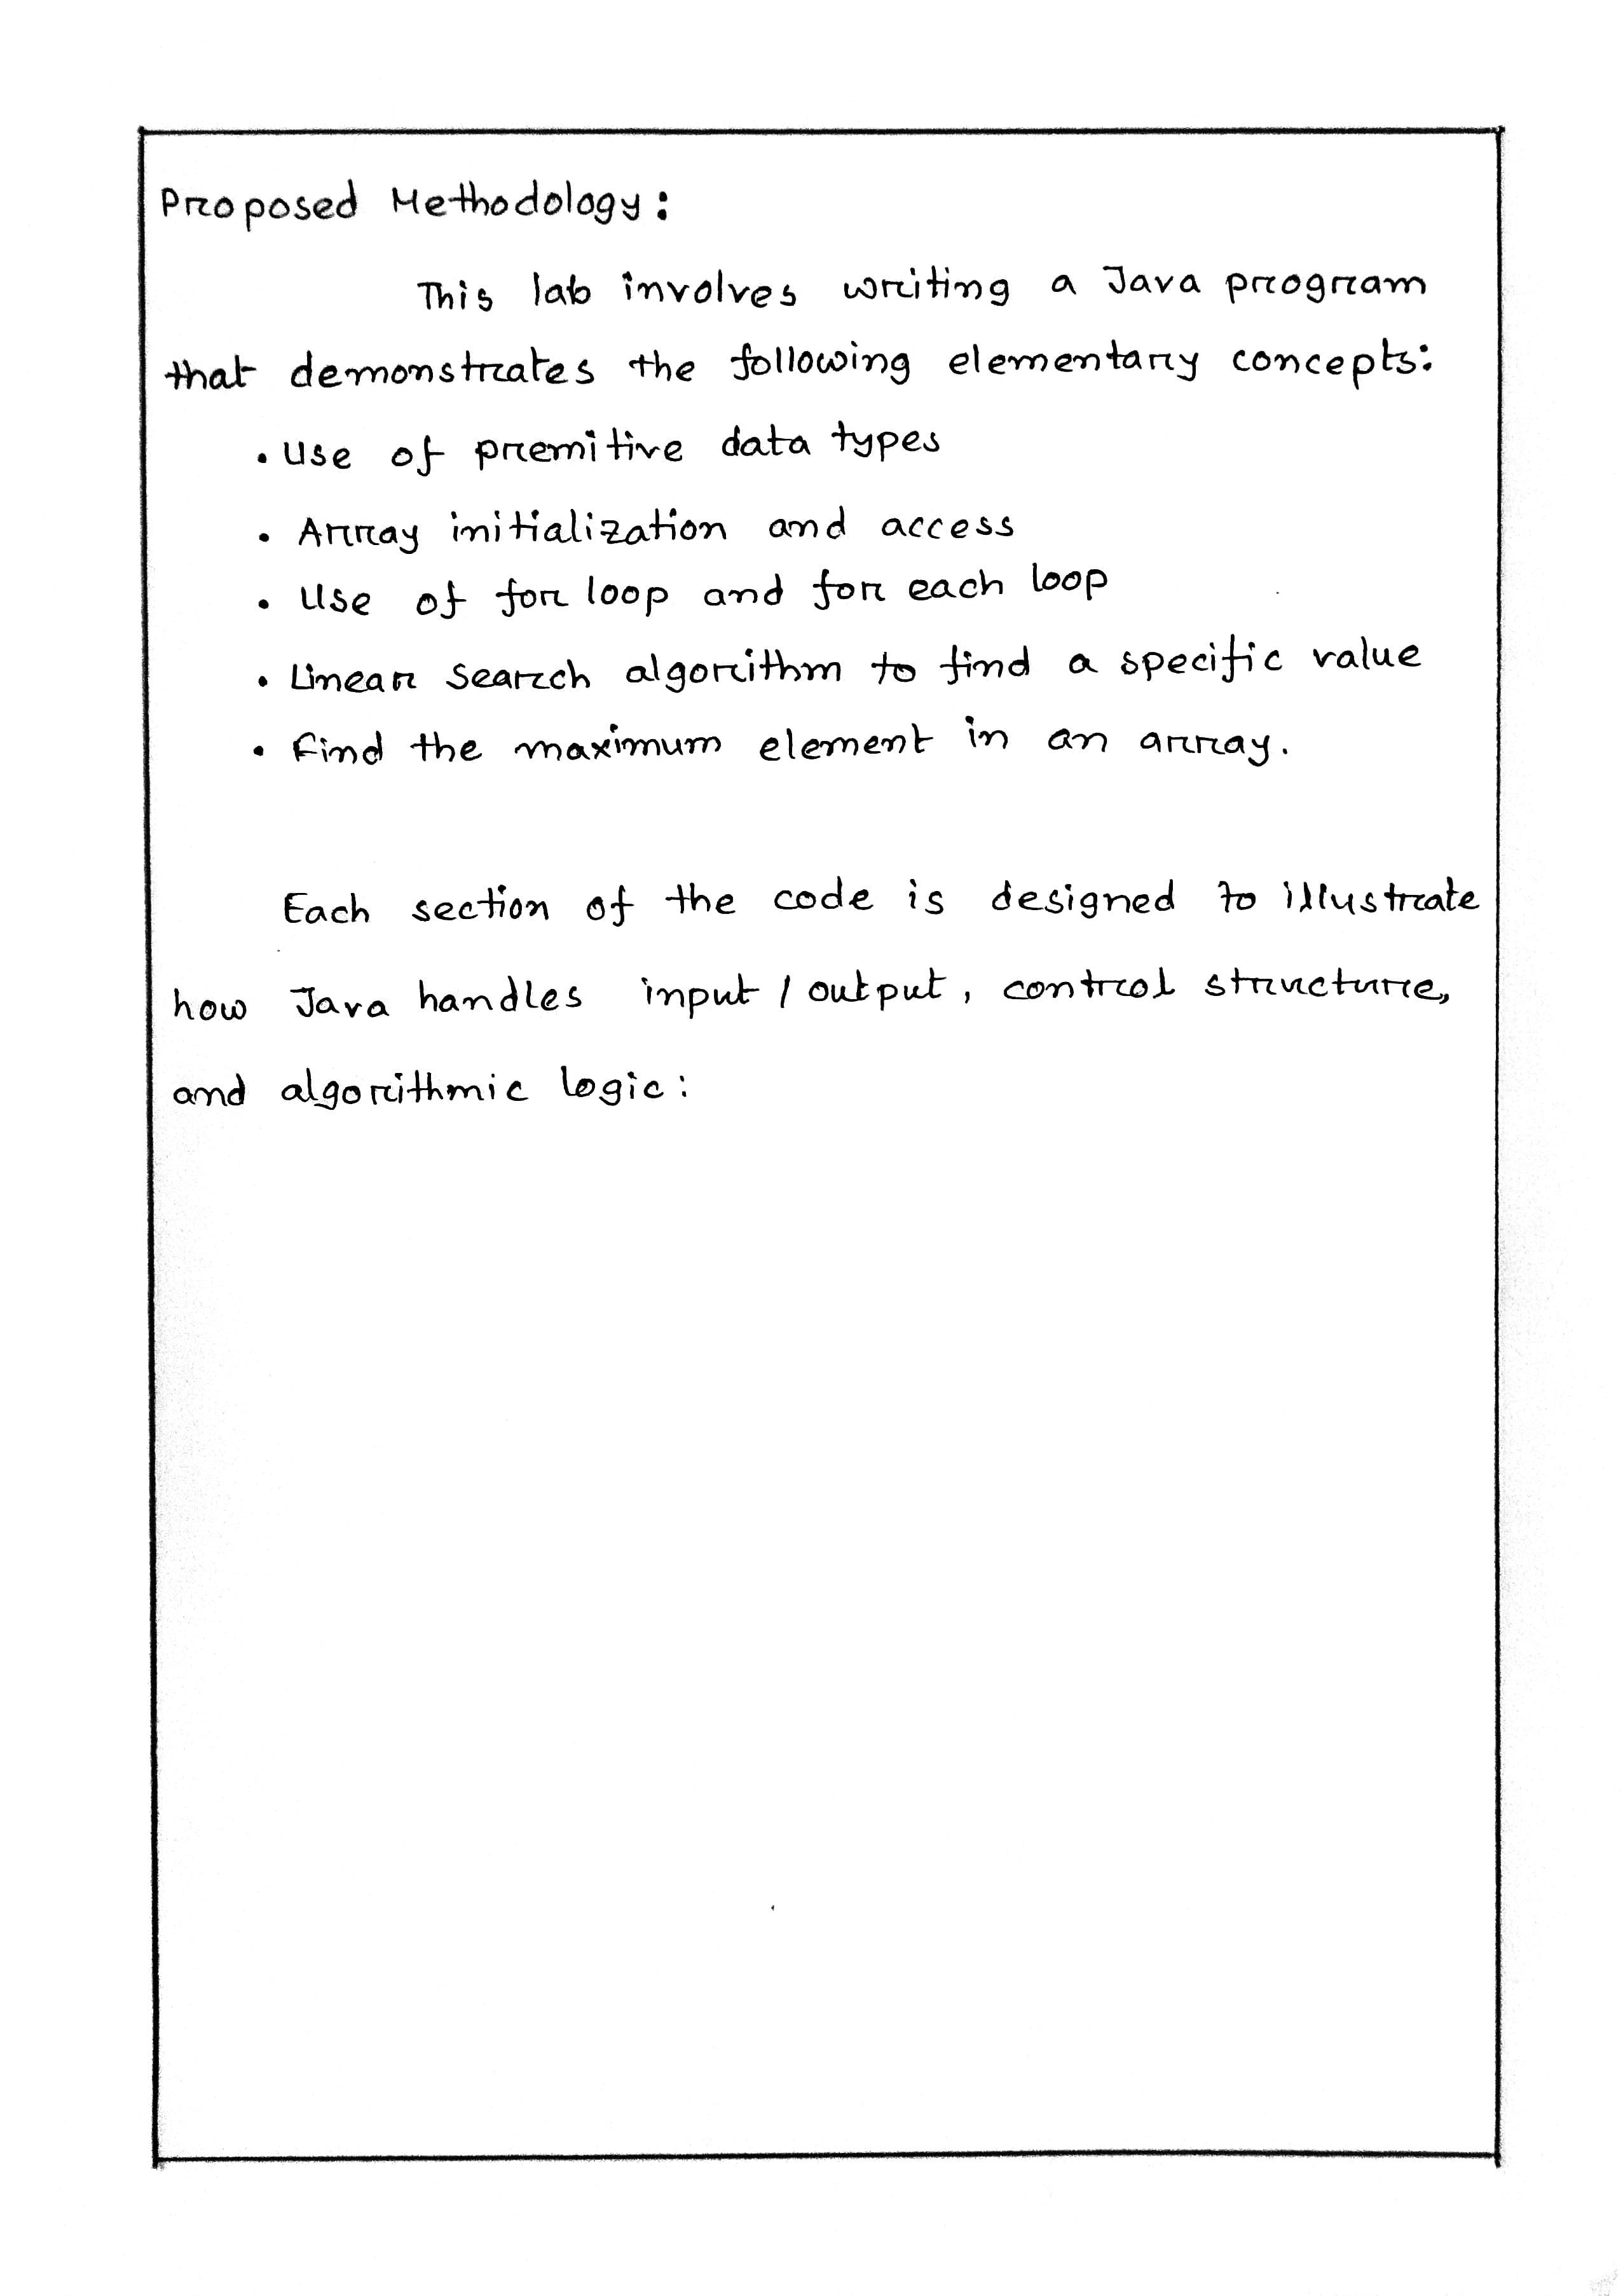

Program Name: A program print data type in Java
Code:
public class dataType {
public static void main(String[] args){
byte a = 10;
short b = 100;
int c = 100000;
char d = 'A';
float e = 3.50f;
double f = 3.4567;

System.out.println(a);
System.out.println(b);
System.out.println(c);
System.out.println(d);
System.out.println(e);
System.out.println(f);
}
}

Output:
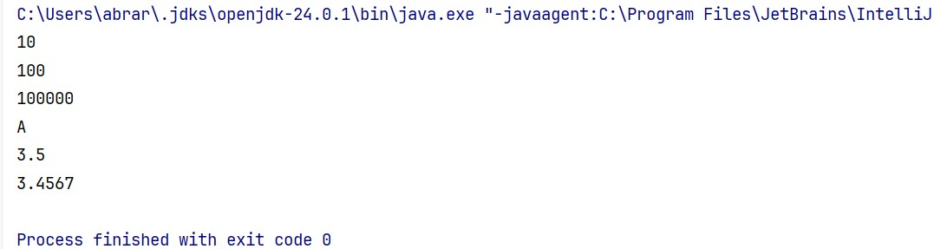

Program Name: A program to access array elements
Code:
public class accessArrayElement {
public static void main(String[] args){
int[] age = {16, 23, 45};
System.out.println("Accessing array elements:");
System.out.println("First Element: " + age[0]);
System.out.println("Second Element: " + age[1]);
System.out.println("Third Element: " + age[2]);
}
}

Output: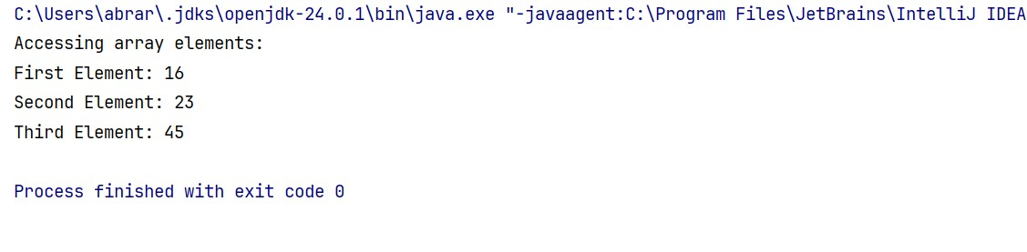
Program Name: A program to implement for loop
Code:
public class forLoopArray {
public static void main(String[] args){
int[] a = {12,23,34,45,56};

for(int i=0; i<a.length; i++){
System.out.println("index[" + i +"] = " + a[i]);
}
}
}
Output:
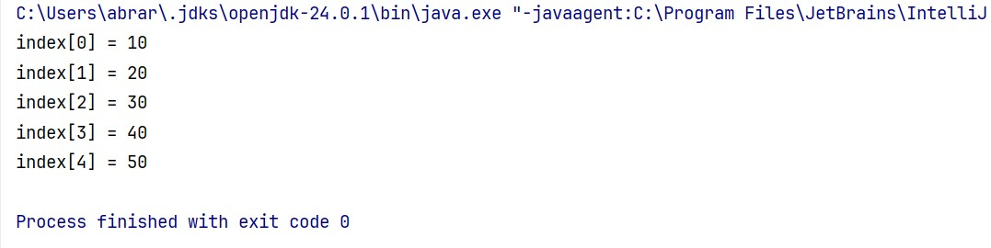

Program Name: A program to implement for each loop
Code:
public class forEachLoopArray {
public static void main(String[] args){
int[] a = {10,20,30,40,50};
int i = 0;
for(int x : a){
System.out.println("index[" + i +"] = " + x);
i++;
}
}
}
Output:
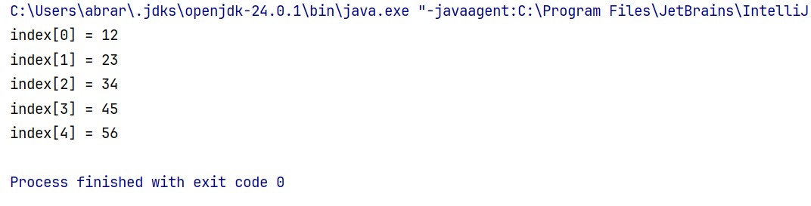

Program Name: A program to search an element in array
Code:
public class linearSearch {
public static void main(String[] args){
int[] a = {10,20,30,40,50};
int item = 40;
int count = 0;
boolean t = true;

for(int x : a){
if(x == item){
t = false;
break;
}
}
System.out.println((t) ? "Item Not Found :(" : "Item Found :)");

}
}
Output:

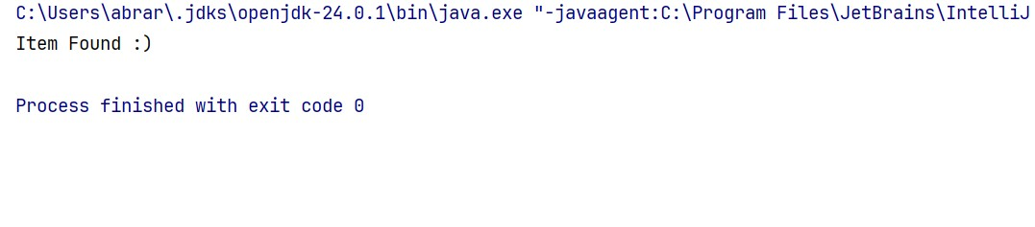
Program Name: A program to find the maximum value in array
Code:
public class maxElement {
public static void main(String[] args){
int[] a = {10,20,30,40,50};
int max = a[0];

for(int i=1; i<a.length; i++){
if(max < a[i]){
max = a[i];
}
}
System.out.println("Maximum Element of the Arrary: " + max);
}
}
Output:
